**Literature Review**

**Nicholas Randles – B00058026**



**Contents**

Abstract………………………………………………………………..………………………………2

Literature Review...........................................................................................................….......2

* Introduction…………………………………………………………....………………….…..2
* What is an Android application……………………………………………………...….…..2
* Why develop and Android application..........................................................................3
* What makes a good Android application……………………………………....……….…4
* Android Application for medical management purposes..............................................5
* Securing user sensitive data in an Android application................................................5
* Conclusion……………………………………………………………………………….…...6

References...............................................................................................................................7

**Abstract**

This Literature review was written to examine research papers based on Android applications and the purpose of them in the medical field. The paper starts off by going in to detail on what an Android application is and what it is made up of. It will then discuss why we choose Android over other mobile device platforms. It then discusses the aspects that make a good application such as privacy. The paper then discusses how mobile applications are being used in the medical industry today by both doctors and patients. It discusses past approaches developers have taken to develop helpful and efficient applications for doctors and their patients. Finally, it will discuss the security threats to android applications and what developers can do to protect their users’ valuable medical information.

**Literature Review**

**Introduction**

The focus of this literature review is to explore the possibility of creating an Android application which can help users’ to manage their medical needs in an efficient way. This literature review will focus in on five main topics of research. The five topics are as follows:

* What is an Android application?
* Why develop and Android application?
* What makes a good Android application?
* Android Application for medical management purposes
* Securing user sensitive data in an Android application

**What is an Android application?**

Android is an open source operating system that is based on the Linux platform. It is composed of an operating system, middleware, user interface and application software. It is mainly used for mobile devices and tablets. It is developed by the Open Handset Alliance which is composed of over 30 technology companies, some of which include Google, HTC, Motorola, Samsung and LG [1]. Android promotes the Google enterprise target achievement which is “provide information for everyone at any time in any place” [2]. According to [3], Android has the following 5 characteristics:

* It is a completely open and free mobile phone software platform available to all developers.
* The android platform has no boundaries. Applications are able to access the core mobile device with the standard API.
* All applications on Android are equal. This means they can be replaced and extended.
* Applications can be embedded into JavaScript and HTML.
* Applications are able to run at the same time since Android is a complete multi-task environment.

The Android platform architecture can be split into four layers [4]. They are illustrated in Figure 1 from highest to lowest.

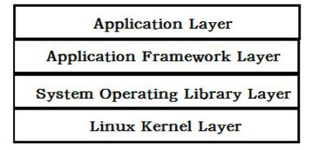

Figure 1: Android Platform Architecture [4]

1. Application layer: This layer refers to the programs that are written in Java and run in the virtual machine. For example, Google provides many applications into the system such as a calendar and a browser.
2. Application Framework layer: This layer refers to the API frameworks which are provided by Google developers to help other developers to create their own applications easier through these frameworks.
3. System Operating Library Layer: This layer refers to the libraries provided to developers to help them with the application development. Examples of this include OpenGL and SQLite.
4. Linux Kernel Layer: This layer refers to the Linux kernel, which is the layer between the hardware and software stacks. It provides core services such as memory and process management, security and driving model.

**Why develop and Android application?**

Mobile application development is the fastest growing trend in the Information Technology industry. There is a high demand for mobile application development and this is supported by [5] who have shown that mobile ownership overtook desktop ownership in 2014. This is illustrated in Figure 2.

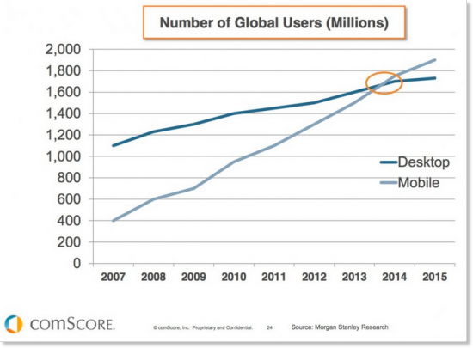

Figure 2: Global growth of mobile devices [5]

There is a wide range of different mobile operating system to choose from. In order to choose which operating system is the best chose we need to look at trends and advantages some may have over others. According to [6] Android had the majority of the market share at 52% in the United States in 2013. This is illustrated in Figure 3.

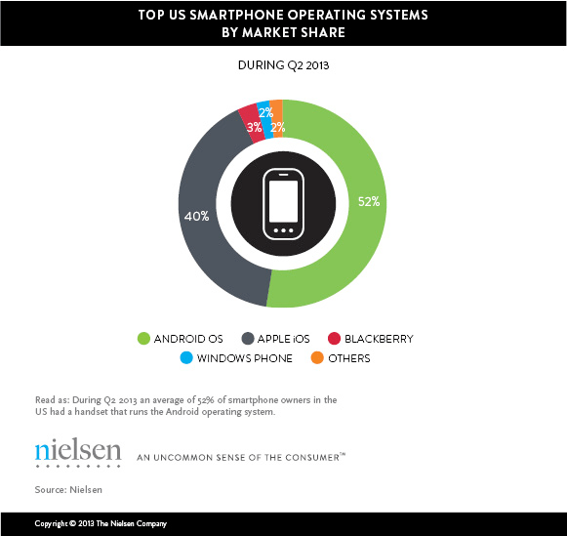

Figure 3: Operating System market shares [6]

Not only is the user base much bigger than other operating systems but the developer tools are better according to [7]. [7] said that Apple app developers have started to cross over to Android because it provides better tools for its developers and is also a lot more flexible than Apple OS development. Apple have a very strict policy when it comes to developers trying to get their applications onto iOS. Unlike Apple, Android is open and its software developer kit helps developers get their applications across as many platform as possible [8].

**What makes a good Android application?**

Privacy is a very important part of mobile applications for mobile device users. Many mobile device users believe it is especially important when it comes to dealing with personal health related information. It is important that mobile application developers develop privacy policies in meaningful ways that meet the requirements of their intended target audience [9]. The problem with most privacy policies is that they are written in a way which makes it hard for the user to understand or makes them completely ignore them. A survey of 584 university students showed that most of them do not read privacy policies completely, but they would be worried if their information was shared with a third party [10].

Users have lost trust in applications over the years as stories come out about personal data being shared secretly and illegally with advertisers [11]. The U.S Federal Trade Commission (FTC) announced that after conducting a basic investigation into 12 popular health and fitness applications, they found that they were sharing their users’ personal data with 76 different third parties [12].

Developers now have to gain their users’ trust by clearly explaining the data their collecting from them, how it’s being used and who it’s being shared with. They need to take into account their users’ reading comprehension levels when they create their privacy policies. Failure to understand the privacy policy could lead to the user sharing personal health information that they did not intend to, or it could prevent the user from installing the application due to their privacy concerns. Readability tests can be conducted to examine the difficulty of the vocabulary and the structure of the sentences in the privacy policy. It is recommended that documents for health instructions be written at a 5th grade level [13].

In Android, applications must request to share resources, data and device features such as GPS, camera and contacts. [14] says that there is evidence to support that some users are sometimes confused by this application permission model. Users can review the necessary permissions required for an application in the Google Play Store before they download it [15].

**Android Application for medical management purposes**

Mobile medical applications have really changed the health care system for the better over the last few years. These advancements are really needed in this day and age because of the increasing aging population of the world. They are providing doctors and their patients a number tools and resources to help them manage their health [16]. A survey at a Canadian medical school found that 85% of students owned smartphones and often used medical apps to reference disease diagnoses and medications [17]. A review on academic literature by [18] found most apps targeted at patients focused on certain health conditions, health diaries and medical calculators.

There are many different approaches to medical applications out there, one research paper [19], discussed an application to monitor a patients vitals. [19] allows doctors to view up to date information of the patients’ vital health parameters such as, heart rate and blood pressure. The doctors can monitor these results and make notes on them. If the patients vital levels go below a critical limit their doctor will be notified that their patient is in danger.

Another medical application approach was discussed in the research paper [20]. [20] is a mobile application which aims to stop the common problem of misinterpreted drug prescriptions. This has been a serious problem in the medical field which has led to the deaths of thousands of people [21]. It can be caused by the doctor’s sloppy handwriting or inability of the pharmacist to correctly interpret the drug name on the prescription. This application allows users to take a picture of the prescription with their phone camera. The picture is then processed by the handwriting recognition algorithm and returns the matching result from the database.

**Securing user sensitive data in an Android application**

Since Android is the leading platform of the smartphone market it is a big target by many computer criminals [22]. Smartphones often contain important information such as medical information and it is important that this information is not leaked as it can be a serious loss to the android smartphone user. To prevent private information being leaked Android uses a different technique compared to more typical operating systems that rely on third party applications. Android have their own built in security scheme instead [23].

Not all users stay up to date with the most current version of Android though, this means they are more vulnerable as they have not received the necessary security updates. [24] says that only 13.6% of all android devices are using the latest version of android.

Security is divided into three categories, they are as follows:

Vulnerability: This is a weakness in the system that may be a security threat [25].

Threat: This is everything that can be done to harm the system by using the vulnerability [26].

Control: This is the process of trying to stop the harm of the threat [26].

If the security is perfect there will be no serious threats or vulnerabilities to take advantage of.

Some of the security features of Android which help developers to build secure applications include the following [27]:

* The Android Application Sandbox: This isolates your application’s data and code execution from other applications.
* An application framework that has strong security functionality including permissions, secure IPC and cryptography.
* An encrypted filesystem which the user can be enabled when their device is lost or stolen to protect important data.

**Conclusion**

Based upon the research that has been currently undertaken in the field of Android applications it seems like it is very possible to create an Android application which enables users to efficiently manage their medical needs. The information in this literature review will have a very positive impact on the development of our Android application. This literature review has shown us a detailed look on how android applications are developed and why they should be developed over other mobile application options. It has shown us what it takes to create a good application by implementing user friendly aspects such as a privacy policy. We have seen security issues in Android and ways to resolve them. This will help us to make our application more secure. This literature review has also provided us with different approaches that other developers took to create medical applications in Android. We can take these approaches and learn from them and try to improve on their mistakes.

**References**

[1] Shao Guo-Hong, "Application development research based on android platform," in *Intelligent Computation Technology and Automation (ICICTA), 2014 7th International Conference on,*2014, pp. 579-582.

[2] Developers A. What is Android[J]. 2011

[3] ZHANG S C. Development and Research of Application Based on Google Android [J][J]. Computer Knowledge and Technology, 2009, 28.

[4] Brahler S. Analysis of the android architecture[J]. Karlsruhe institute for technology, 2010.

[5] Danyl Bosomworth, *Mobile marketing statistics 2015*

[6] Nielsen, *Who's Winning the U.S. Smartphone Market, 2013*

[7] T. Bradshaw, "Apple's app advantage wanes as developers warm to Android," *The Financial Times,*pp. 1, 12/28; 2015/11, 2012.

[8] A. Stevenson, "Top 10 Android benefits over Apple iPhone," *V3.Co.Uk,*03/28; 2015/11, 2014.

[9] M. Rowan and J. Dehlinger, "A Privacy Policy Comparison of Health and Fitness Related Mobile Applications," *Procedia Computer Science,*vol. 37, pp. 348-355, 2014.

[10] Rowan, M. and Dehlinger, J. Privacy incongruity: an analysis of a survey of mobile end-users. 13th International Conference on Security and Management. 2014.

[11] Steinberg, J. (2013, December 6). This flashlight android app has been secretly and illegally sharing your personal data with advertisers. Retrieved from: http://www.forbes.com/sites/josephsteinberg/2013/12/06/this-flashlight-android-app-has-been-secretly-and-illegally-sharing-your-personal-data-with-advertisers/.

[12] Slabodkin, G. (2014, May 8). FTC concerned with health data sharing apps. Retrieved June 10, 2014 from: http://www.healthdatamanagement.com/news/FTC-Concerned-with-Health-Data-Sharing-Apps-48017-1.html.

[13] Dubay, W. (2004, August 25). Principles of readability. Retrieved June 12, 2014 from: http://www.impactinformation.com.

[14] Phandroid Forums. (2012, October 31). Confused over app permissions. Retrieved June 11, 2014 from: http://androidforums.com/android-applications/641501-confused-over-app-permissions.html.

[15] Google Play. (2014). Review app permissions. Retrieved June 10, 2014 from: https://support.google.com/googleplay/answer/60149727.

[16] H. J. Seabrook, J. N. Stromer, C. Shevkenek, A. Bharwani, J. de Grood and W. A. Ghali, "Medical applications: a database and characterization of apps in Apple iOS and Android platforms," *BMC Research Notes,*vol. 7, pp. 573, 08/27; 2015/11, 2014.

[17] Wallace S, Clark M, White J: ?It?s on my iPhone?: attitudes to the use of mobile computing devices in medical education, a mixed-methods study. BMJ Open 2012, 2(4): 1-7.

[18] Mosa ASM, Yoo I, Sheets L: A systematic review of healthcare applications for smartphones. BMC Med Inform Decis Mak 2012, 12(1): 67

[19] S. Challa, G. Geethakumari and C. S. N. Prasad, "Patient data viewer: An android application for healthcare," in India Conference (INDICON), 2011 Annual IEEE, 2011, pp. 1-4.

[20] R. B. Alday and R. M. Pagayon, "MediPic: A mobile application for medical prescriptions," in *Information, Intelligence, Systems and Applications (IISA), 2013 Fourth International Conference on,*2013, pp. 1-4.

[21] Jeremy C. 2007. Cause of Death: Sloppy Doctors http://www.time.com/time/ health/artic le/0,8599,1578074,00.html

[22] E. Sugiono, Y. Asnar and I. Liem, "Android security assessment based on reported vulnerability," in *Data and Software Engineering (ICODSE), 2014 International Conference on,*2014, pp. 1-6.

[23] C. Nachenberg, "A Window Into Mobile Device Security,” Symantec, 2011.

[24] Google. (2014, Jun.) Google Developer. [Online]. https://developer.android.com/about/dashboards/index.html [Last Accessed on June 2014, 25]

[25] NIST, SP800-3-Risk Management Guide for Information Technology Systems. Gaithersburg: National Institute Of Standart and Technology, 2002.

[26] C. P. Pfleeger and S. L. Pfleeger, Analyzing Computer Security: A Threat/Vulnerability/Countermeasure Approach. New jerseys: Prentice Hall, 2012.

[27] *Security Tips | Android Developers,* [Last Accessed on 11/29/2015*].*